Assignment-1.2
- Akshay
2303A51817 - Batch-26

SCHOOL OF COMPUTER SCIENCE AND ARTIFICIAL INTELLIGENCE |  |  |  |  | DEPARTMENT OF COMPUTER SCIENCE ENGINEERING
Program Name: B. Tech |  |  |  | Assignment Type: Lab |  |  | Academic Year:2025-2026
Course Coordinator Name |  |  |  | Dr. Rishabh Mittal
Instructor(s) Name
  Mr. S Naresh Kumar
  Ms. B. Swathi
  Dr. Sasanko Shekhar Gantayat
  Mr. Md Sallauddin
  Dr. Mathivanan
  Mr. Y Srikanth
  Ms. N Shilpa
  Dr. Rishabh Mittal (Coordinator)
  Dr. R. Prashant Kumar
  Mr. Ankushavali MD
  Mr. B Viswanath
  Ms. Rapelly Nandini
  Ms. A. Anitha
  Ms. M.Madhuri
  Ms. Katherashala Swetha
  Ms. Velpula sumalatha
  Mr. Bingi Raju
CourseCode |  |  | 23CS002PC304 | Course Title |  | AI Assisted Coding
Year/Sem |  |  | III/II | Regulation |  | R23
Date and Day  of Assignment |  |  | Week1 - Tuesday | Time(s) |  | 23CSBTB01 To 23CSBTB52
Duration |  |  | 2 Hours | Applicable to  Batches |  | All batches
Assignment Number:1.2(Present assignment number)/24(Total number of assignments)
 | Q.No. | Question |  |  |  |  |  | Expected Time  to complete
 | 1 | Lab 1: Environment Setup – GitHub Copilot and VS Code Integration + Understanding AI-assisted Coding Workflow  Lab Objectives:  - To install and configure GitHub Copilot in Visual Studio Code.  - To explore AI-assisted code generation using GitHub Copilot.  - To analyze the accuracy and effectiveness of Copilot's code suggestions.  - To understand prompt-based programming using comments and code context  Lab Outcomes (LOs):  After completing this lab, students will be able to:  - Set up GitHub Copilot in VS Code successfully.  - Use inline comments and context to generate code with Copilot.  - Evaluate AI-generated code for correctness and readability.  - Compare code suggestions based on different prompts and programming styles.  Task 0  - Install and configure GitHub Copilot in VS Code. Take screenshots of each step.  Expected Output  - Install and configure GitHub Copilot in VS Code. Take screenshots of each step.  Task 1: AI-Generated Logic Without Modularization (Factorial without Functions)  - Scenario  You are building a small command-line utility for a startup intern onboarding task. The program is simple and must be written quickly without modular design.  - Task Description  Use GitHub Copilot to generate a Python program that computes a mathematical product-based value (factorial-like logic) directly in the main execution flow, without using any user-defined functions.  - Constraint:  - Do not define any custom function  - Logic must be implemented using loops and variables only  - Expected Deliverables  - A working Python program generated with Copilot assistance  - Screenshot(s) showing:  - The prompt you typed  - Copilot’s suggestions  - Sample input/output screenshots  - Brief reflection (5–6 lines):  - How helpful was Copilot for a beginner?  - Did it follow best practices automatically?  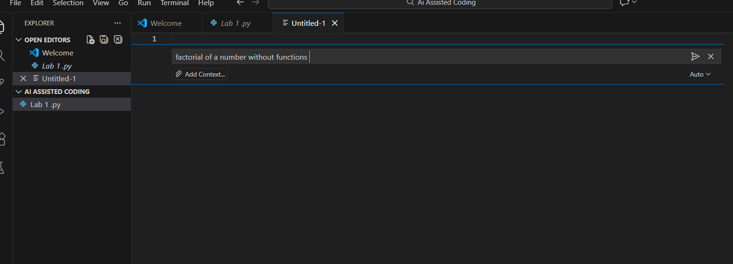  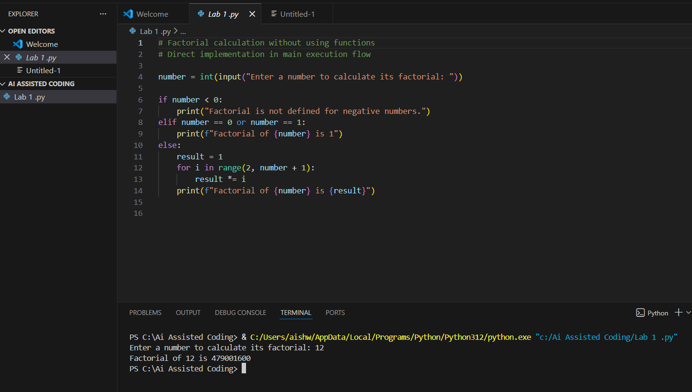  Explanation: This Program Calculates the factorial of a number.If negative number is entered the factorial is not defined .  Task 2: AI Code Optimization & Cleanup (Improving Efficiency)  - Scenario  Your team lead asks you to review AI-generated code before committing it to a shared repository.  - Task Description  Analyze the code generated in Task 1 and use Copilot again to:  - Reduce unnecessary variables  - Improve loop clarity  - Enhance readability and efficiency  Hint:  Prompt Copilot with phrases like  “optimize this code”, “simplify logic”, or “make it more readable”  - Expected Deliverables  - Original AI-generated code  - Optimized version of the same code  - Side-by-side comparison  - Written explanation:  - What was improved?  - Why the new version is better (readability, performance, maintainability.  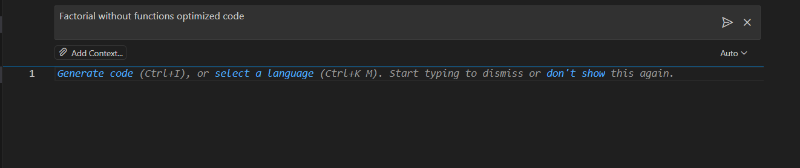  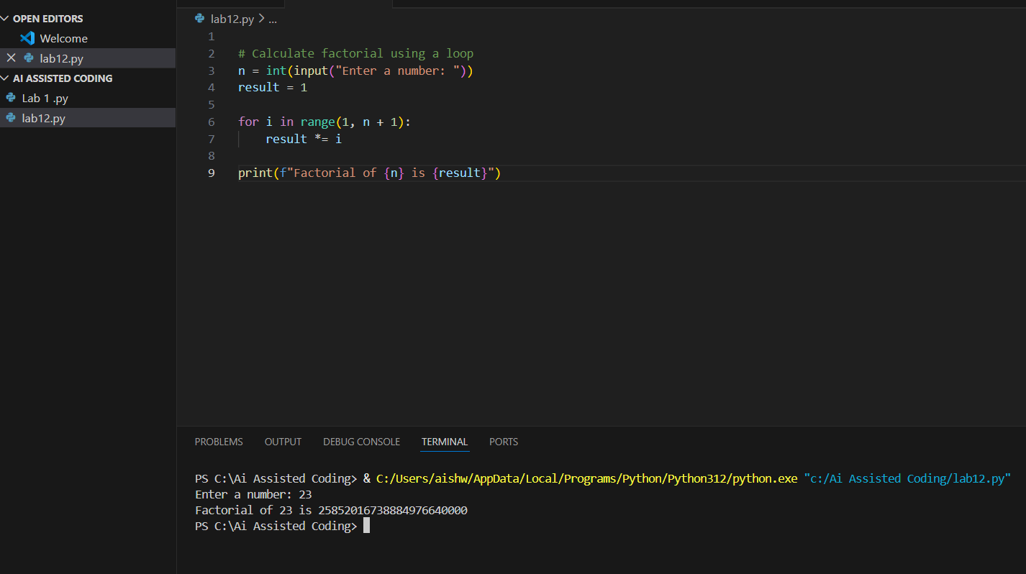  Explain : Optimized code removes unnecessary conditions simplifies the logic which makes it more understandable and maintainable .  Task 3: Modular Design Using AI Assistance (Factorial with Functions)  - Scenario  The same logic now needs to be reused in multiple scripts.  - Task Description  Use GitHub Copilot to generate a modular version of the program by:  - Creating a user-defined function  - Calling the function from the main block  - Constraints  - Use meaningful function and variable names  - Include inline comments (preferably suggested by Copilot)  - Expected Deliverables  - AI-assisted function-based program  - Screenshots showing:  - Prompt evolution  - Copilot-generated function logic  - Sample inputs/outputs  - Short note:  - How modularity improves reusability.  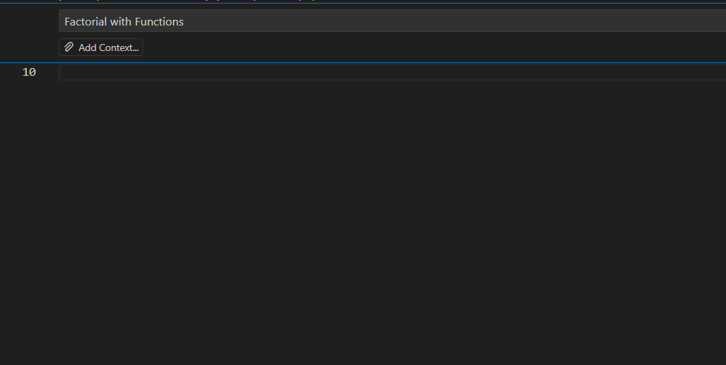  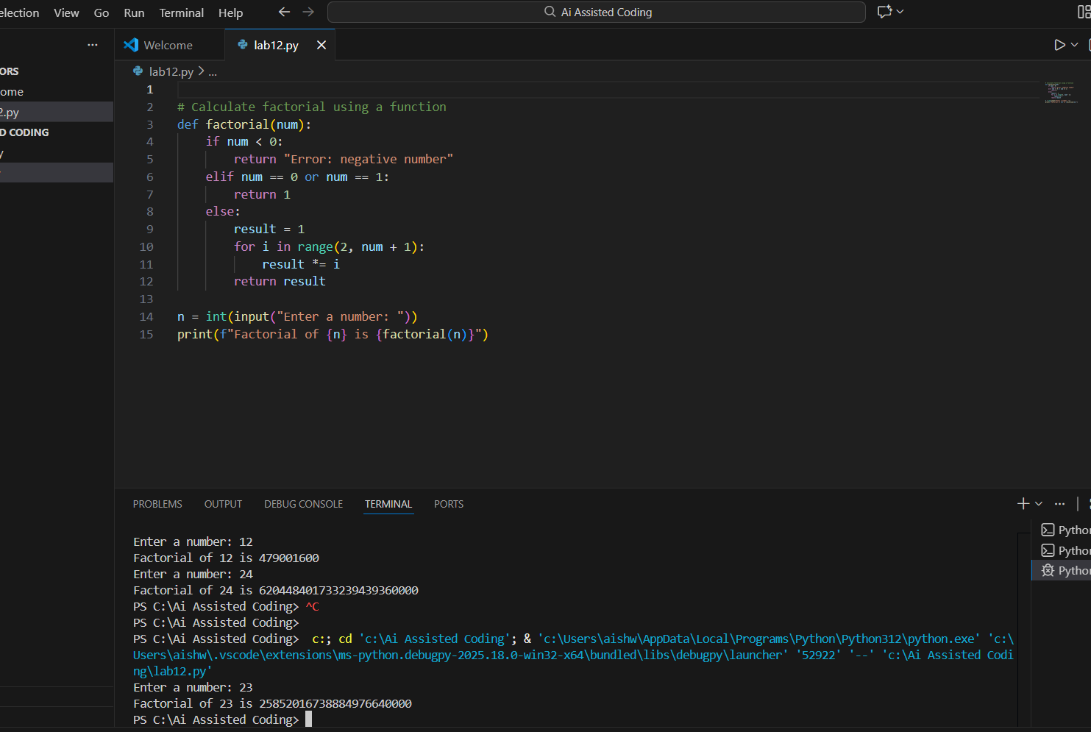  Explanation : This Program calculates the factorial using user defined function .  This condition avoids unnecessary calculations .  Task 4: Comparative Analysis – Procedural vs Modular AI Code (With vs Without Functions)  - Scenario  As part of a code review meeting, you are asked to justify design choices.  - Task Description  Compare the non-function and function-based Copilot-generated programs on the following criteria:  - Logic clarity  - Reusability  - Debugging ease  - Suitability for large projects  - AI dependency risk  - Expected Deliverables  Choose one:  - A comparison table  OR  - A short technical report (300–400 words).  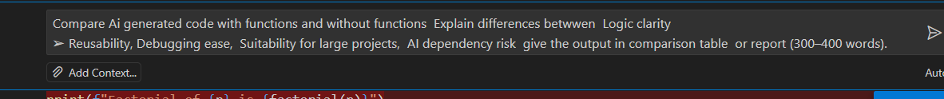  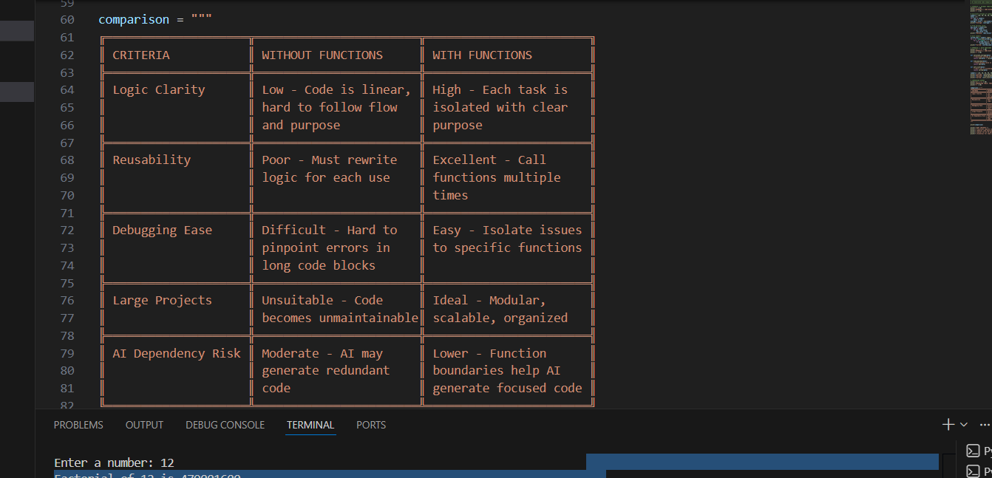  Explanation : This table shows that writing code with functions is better than writing code without functions because functions make the logic clearer, allow code reuse, simplify debugging, and help manage large projects efficiently. Code without functions is harder to understand, difficult to maintain, and often leads to repetitive or messy code, while functions keep programs modular and organized.  Task 5: AI-Generated Iterative vs Recursive Thinking  - Scenario  Your mentor wants to test how well AI understands different computational paradigms.  - Task Description  Prompt Copilot to generate:  An iterative version of the logic  A recursive version of the same logic  - Constraints  Both implementations must produce identical outputs  Students must not manually write the code first  - Expected Deliverables  Two AI-generated implementations  Execution flow explanation (in your own words)  Comparison covering:  - Readability  - Stack usage  - Performance implications  - When recursion is not recommended.  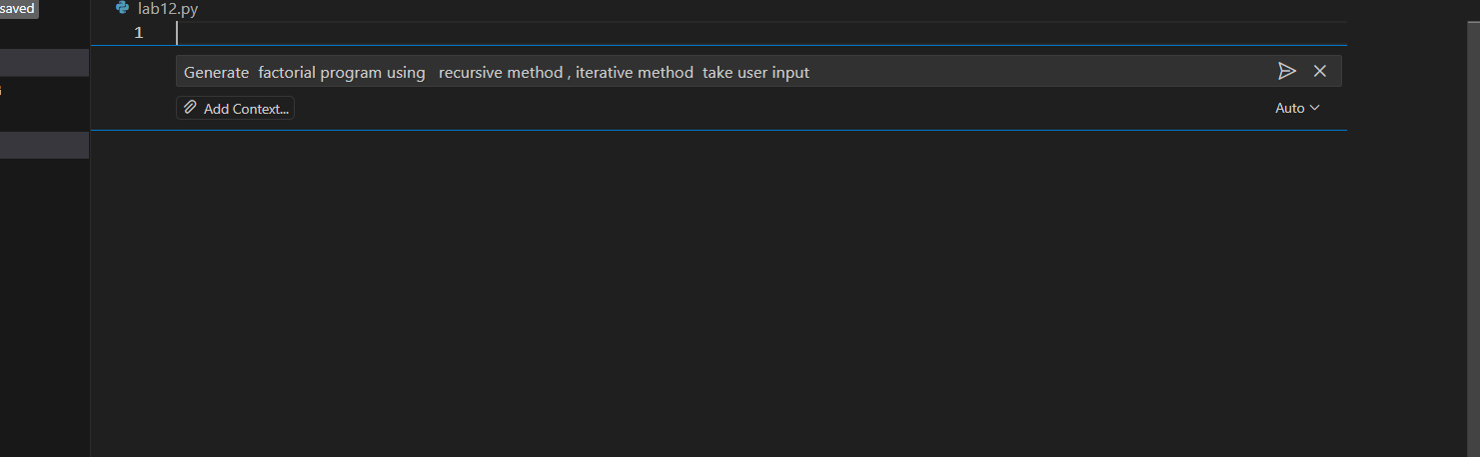  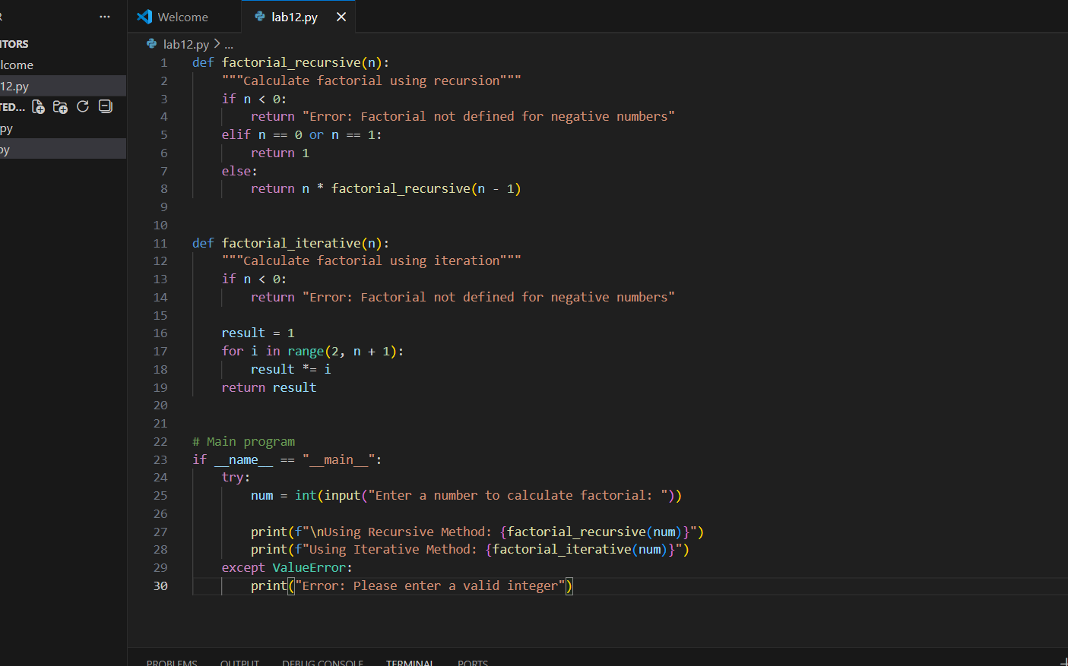  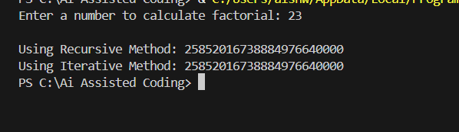  Explanation : This program finds the factorial of a number using both recursive and iterative methods. The recursive function calls itself until it reaches the base case, while the iterative function uses a loop to calculate the result. Both methods give the same output for valid inputs. Recursion is easier to understand but uses more memory, whereas iteration is more efficient and safer for large numbers.  Submission Requirements  - Generate code for each task with comments.  - Screenshots of Copilot suggestions.  - Comparative analysis reports (Task 4 and Task 5).  - Sample inputs/outputs demonstrating correctness.  Note: Report should be submitted as a word document for all tasks in a single document with prompts, comments & code explanation, and output and if required, screenshots. |  |  |  |  |  | Week1 - Monday

